Year 11 Mathematics Specialist
Test 3 –2015
Total Time: | 55minutes | /55  ------%
Total Reading: | 3 minutes
Total Working: | 58 minutes
Weighting: | % of the year.
Equipment: | SCSA Formula Sheet; ½ page notes (A4 one side), CAS  calculator; Scientific Calculator

1. [7 marks]
Two tangents are drawn from point T to points A and B on a circle as shown in the diagram. Given the angle between the tangents is 44⁰ calculate the size of showing proof of each result.

2. [8 marks]
Consider point M external to the circumference of the circle centre C. A secant is drawn from M passing through the centre C also intersecting the circumference of the circle at 2 points A and B. A line is also drawn from M to the circle at a point of tangency T.

3. [7 marks]
A group of 67 Year 9 students responded to a survey stating they owned one or more of the following items.

A: An internet connected mobile phone
B: A tablet or iPad
C: A laptop computer

The following information was recorded using set notation
n(A) = 37, n(B) = 28 and n(C) = 32 and the following notes were made.

There were as many students who owned all three as those who owned a phone and iPad but not a laptop.

There were as many students who owned all three as those who owned a laptop and iPad but not a phone.

There were twice as many students who owned a phone and laptop but not an iPad as those who owned all three.

- Calculate how many students owned all three devices.

- Calculate how many students owned only one of these devices.

4. [5 marks]

In ΔABC, the points M and N divide the sides AB and AC respectively in the ratio 1 : 3. Let AB = u and AC = v. Find BC and MN in terms of u and v, and hence prove that BC = 4MN.

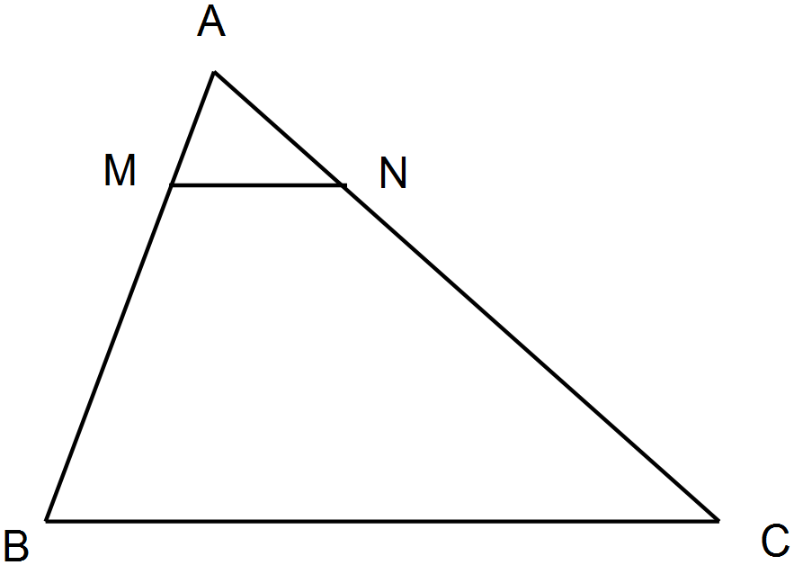

5. [4 marks]

State whether each of the following are true (T) or false (F):

i. The contrapositive of a true statement is always true. _____

ii. The converse of a true statement is always true. _____

iii. The “equivalent” symbol used in proofs in Mathematics is⇔ _______

iv. The converse to the statement, “A triangle is a polygon.”

is “A polygon is a triangle.” _____
6. [12 marks: 7, 4, 1]
Two forces act on an object in a flat plane. F₁ has a magnitude of 4 newtons and acts on a bearing of 035⁰ and F₂ with a magnitude of 5 newtons acts on a bearing 113⁰.

- Use the triangle rule to calculate the magnitude and direction of the resultant force to an accuracy of two (2) decimal places.

- Calculate the i and j components of F₁ and F₂ given the unit vector i is on a bearing 0⁰ T and the unit vector j is on a bearing 90⁰ T

- Evaluate F₁ + F₂ in i and j component form.

7. [3 marks]

Use proof to show that a triangle with sides 8 cm, 15 cm and 17 cm is right angled.

8. [5 marks]

In Triangle ABC below, AD = 13 cm, DB = 5 cm, AE = 9 cm and DE = 5 cm.
Prove that BC = 10 cm.
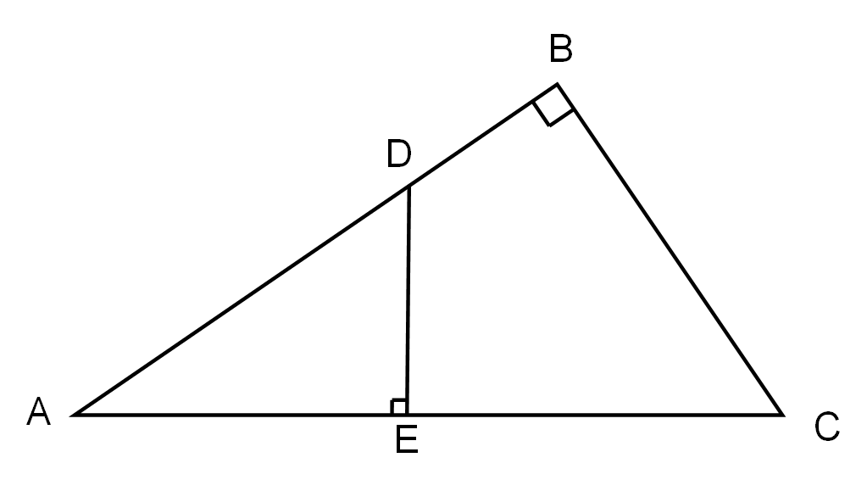

END OF TEST

